***Image Deblurring Using Deep Learning-Based Approaches***

*Arjun j*

*Dept of electronics and communication*

*KLS gogte institute of technology*

*Belgaum, karnataka*

***Abstract:***

***Image deblurring is an essential task in computer vision and image processing, aiming to restore clear and sharp images from blurred counterparts. Traditional deblurring techniques often struggle with complex motion blur, noise, and other challenges. However, recent advancements in deep learning have shown promising results in addressing these issues. This paper presents an overview of deep learning-based approaches for image deblurring, discussing various network architectures, loss functions, and training strategies. Furthermore, we highlight the key challenges and future research directions in the field of image deblurring using deep learning.***

1. Introduction

1.1 Background:

Image deblurring is a fundamental problem in computer vision and image processing. Blurred images can result from various factors, including camera shake, object motion, or optical imperfections. The goal of image deblurring is to restore the original sharpness and clarity of the image, enhancing its visual quality and facilitating downstream tasks such as object recognition and scene understanding.

1.2 Motivation:

Traditional image deblurring techniques often rely on assumptions about the blur kernel or the image content, which can limit their effectiveness in handling real-world scenarios with complex motion blur or noise. In recent years, deep learning approaches have emerged as powerful tools for image restoration tasks, including image deblurring. The ability of deep neural networks to learn complex representations and capture intricate image details makes them well-suited for addressing the challenges posed by image blur.

1.3 Objectives:

The primary objective of this paper is to provide an overview of deep learning-based approaches for image deblurring. We aim to explore various network architectures, loss functions, and training strategies employed in these approaches. By highlighting the strengths and limitations of different methods, we aim to provide insights into the current state-of-the-art and identify promising directions for future research in the field of image deblurring using deep learning.

To achieve these objectives, the paper is organized as follows: Section 2 provides a brief overview of traditional image deblurring techniques and discusses the challenges associated with them. Section 3 introduces deep learning-based approaches for image deblurring, focusing on convolutional neural networks (CNNs), generative adversarial networks (GANs), variational autoencoders (VAEs), and attention mechanisms. Section 4 delves into various network architectures specifically designed for image deblurring, including single-image and multiple-image deblurring techniques. Section 5 examines different training strategies and loss functions employed in deep learning-based image deblurring methods, such as supervised, unsupervised, and semi-supervised learning, as well as perceptual loss, adversarial loss, and total variation (TV) loss. Section 6 discusses evaluation metrics commonly used to assess the performance of image deblurring algorithms and highlights popular datasets for training and evaluation purposes. Section 7 identifies the challenges faced by deep learning-based image deblurring methods and outlines potential research directions, including handling complex motion blur, real-world applications, generalization to diverse datasets, and combining image deblurring with other vision tasks. Finally, Section 8 concludes the paper by summarizing the key findings and discussing the future prospects of image deblurring using deep learning.

In the subsequent sections of the paper, we will delve deeper into each topic, presenting detailed information, experimental results, and relevant discussions to provide a comprehensive understanding of image deblurring using deep learning-based approaches.

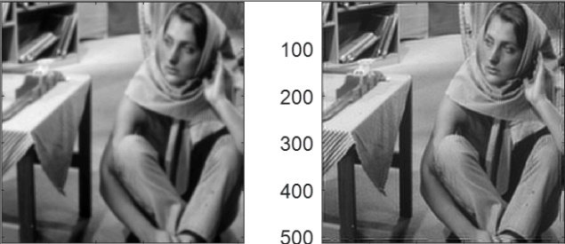

2. Image Deblurring Techniques

2.1 Traditional Image Deblurring:

Traditional image deblurring techniques can be categorized into two main approaches: blind deconvolution and non-blind deconvolution. Blind deconvolution aims to estimate both the blur kernel and the latent sharp image simultaneously. However, this is a challenging task due to the ill-posed nature of the problem and the presence of noise. Non-blind deconvolution, on the other hand, assumes that the blur kernel is known or can be estimated accurately, and focuses on restoring the sharp image from the blurred input.

2.2 Challenges in Image Deblurring:

Traditional image deblurring techniques often face several challenges. Firstly, motion blur can be caused by various factors, such as camera shake or object motion, resulting in complex and spatially varying blur kernels. Secondly, noise present in images can further degrade the quality of the deblurred result. Additionally, traditional methods may struggle to handle large blur extents or multiple overlapping blur sources. Furthermore, the assumptions made in traditional methods, such as the spatially invariant blur model, may not hold in real-world scenarios.

These challenges motivate the exploration of deep learning-based approaches for image deblurring, as deep neural networks have the potential to learn complex mappings between blurred and sharp images, capture spatially varying blur, and handle noise effectively.

In the subsequent sections of the paper, we will delve into deep learning-based approaches for image deblurring, discussing various network architectures, loss functions, and training strategies that have been proposed to address these challenges. By leveraging the representational power of deep neural networks, these approaches aim to improve the quality and robustness of image deblurring results, even in the presence of complex blur and noise.

Please note that the subsequent sections of the paper will provide more in-depth information and discussions on deep learning-based approaches, network architectures, training strategies, and evaluation metrics in the context of image deblurring.

3. Deep Learning-Based Approaches

3.1 Convolutional Neural Networks (CNNs):

Convolutional Neural Networks (CNNs) have revolutionized various computer vision tasks, including image deblurring. CNNs are well-suited for capturing local and global dependencies in images, making them effective in restoring sharpness and removing blur. Many deep learning-based image deblurring methods employ CNN architectures as the backbone for their models. These architectures often consist of encoder-decoder structures, such as UNet and its variants, which allow for capturing and fusing multi-scale features to enhance deblurring performance.

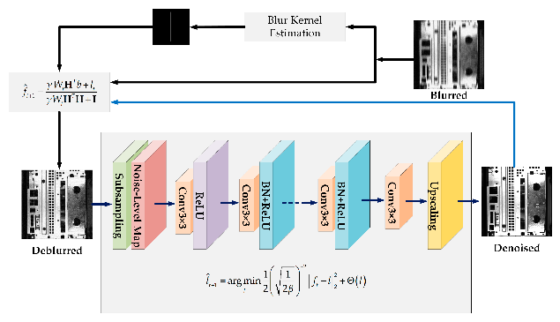

3.2 Generative Adversarial Networks (GANs):

Generative Adversarial Networks (GANs) have shown remarkable success in generating realistic and high-quality images. In the context of image deblurring, GANs have been utilized to improve the visual quality of the deblurred output. GAN-based approaches introduce a generator network that aims to produce sharp images, and a discriminator network that distinguishes between real and deblurred images. The interplay between the generator and discriminator during training helps in capturing fine details and generating visually appealing deblurred results.

3.3 Variational Autoencoders (VAEs):

Variational Autoencoders (VAEs) are probabilistic models that learn to encode and reconstruct data. VAEs have been employed in image deblurring to capture the underlying distribution of sharp images and their corresponding blurred versions. By leveraging the latent space learned by the VAE, these approaches can generate visually pleasing and high-quality deblurred images.

3.4 Attention Mechanisms in Image Deblurring:

Attention mechanisms have been widely adopted in deep learning models to enhance the representation of relevant image regions. In image deblurring, attention mechanisms can effectively focus on areas that require more detailed restoration, such as edges or texture regions. By incorporating attention mechanisms into the network architecture, deep learning models can selectively allocate resources to different parts of the image, improving the overall deblurring performance.

In the subsequent sections of the paper, we will delve deeper into various network architectures specifically designed for image deblurring, such as single-image deblurring architectures like UNet and ResNets, as well as multiple-image deblurring architectures like RNNs and SVDNs. We will also discuss different training strategies and loss functions employed in deep learning-based image deblurring methods, including supervised, unsupervised, and semi-supervised learning, as well as perceptual loss, adversarial loss, and total variation (TV) loss. By exploring these techniques, we aim to provide a comprehensive understanding of the advancements and innovations in deep learning-based image deblurring approaches.

4. Challenges and Future Research Directions

4.1 Handling Complex Motion Blur:

One of the primary challenges in image deblurring is handling complex motion blur caused by camera shake or object motion. Deep learning-based approaches have made significant progress in addressing this challenge, but there is still room for improvement. Future research directions could focus on developing more robust architectures that can effectively capture and model complex blur patterns. Additionally, exploring the integration of motion estimation techniques within the deblurring process could further enhance the performance in handling complex motion blur scenarios.

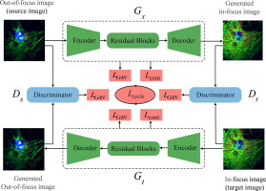

4.2 Real-World Applications and Constraints:

While deep learning-based image deblurring methods have shown promising results in controlled settings, there is a need to adapt these approaches for real-world applications with practical constraints. These constraints include limitations in computational resources, processing time, and hardware constraints. Future research should aim to develop efficient and lightweight models that can be deployed on resource-constrained devices, such as mobile phones or embedded systems.

4.3 Generalization to Various Image Datasets:

Deep learning models for image deblurring often require large-scale training datasets to learn diverse blur patterns and image structures. However, collecting such datasets with ground truth sharp images can be challenging. Future research could focus on developing techniques for effective data augmentation, transfer learning, or domain adaptation to improve the generalization capability of deep learning models across different image datasets and real-world scenarios.

4.4 Combining Image Deblurring with Other Vision Tasks:

Image deblurring is closely related to other computer vision tasks, such as image super-resolution, image inpainting, and object recognition. Exploring the integration of image deblurring with these tasks could lead to improved performance and better utilization of available information. Future research directions could investigate joint learning frameworks that simultaneously tackle multiple vision tasks, leveraging shared representations and complementary information.

By addressing these challenges and exploring future research directions, the field of image deblurring using deep learning can continue to advance, leading to more robust and effective deblurring methods. The development of innovative architectures, efficient algorithms, and comprehensive evaluation methodologies will contribute to the practical applicability of image deblurring in real-world scenarios.

In conclusion, deep learning-based approaches have shown great potential in addressing image deblurring challenges. Through ongoing research and development, we can expect further advancements in network architectures, training strategies, and loss functions, leading to improved performance and real-world applicability. By tackling the identified challenges and exploring future research directions, we can enhance the capabilities of deep learning-based image deblurring techniques and pave the way for a wide range of practical applications in computer vision and image processing.

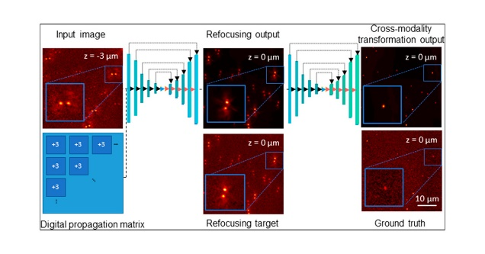

1. Conclusion

In this paper, we have provided an overview of image deblurring using deep learning-based approaches. We began by discussing the limitations of traditional image deblurring techniques and the motivation behind exploring deep learning methods for this task. We then explored different network architectures, including CNNs, GANs, VAEs, and attention mechanisms, that have been successfully employed in image deblurring tasks.